

**CHRISTIAN RELIGIOUS EDUCATION**

**FORM FOUR MECS PAPER ONE MARKING SCHEMES. END TERM I 2023**

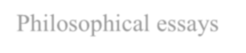

**1 a) Identify seven literary forms used in the writing of the Bible. (7 marks)**

* Wise sayings
* Legal expressions / legislative texts
* Prophetic speeches
* Philosophical essays
* Prayers
* Poetry
* Gospels
* Love Songs
* Epistles/ letters



**First 7x1=7 marks**

1. **State seven similarities in the Biblical stories of creation in Genesis 1 and 2. (7 marks)**

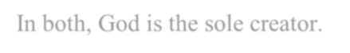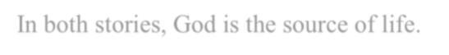

* + In both, God is the sole creator.
  + In both human beings are given responsibilities over God's creation.
  + In both accounts, human beings are special beings.
  + In both stories, God is the source of life.
  + In both, God is self-existent since He existed even before creation.
  + In both, human beings are portrayed as superior with higher dignity.
  + In both, God created male and female separately.
  + In both stories, all created things depend on God for sustenance. God is portrayed as a Provider.

1. **Outline the causes of evil in Kenya today. (7 marks)**
   * Poverty
   * Affluence/ wealth
   * Corruption/ greed/selfishness/lust
   * Disobedience/ rebellion
   * Inability to forgive others
   * Influence from mass media/ foreign culture
   * Wrong choices/ negative peer influence
   * Unemployment
   * Permissiveness/ too much freedom
   * Drugs and substance abuse
   * Poor role model
   * Lack of guidance and counselling/ poor upbringing

**First 7x1=7 marks**



**Any 6x1=6 marks**

**2 a )Describe how the Israelites broke the covenant they had made with God at Mount**

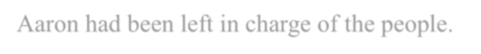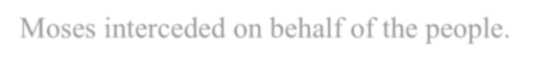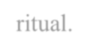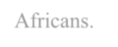

**Sinai (Exodus 32: l-30) (8 marks)**

* Moses had gone up the mountain to seek God’s guidance/instructions.
* Aaron had been left in charge of the people.
* Moses delayed in returning/the people became impatient.
* Israelites asked Aaron to make them a god that would lead them.
* Aaron yielded to the demands of the Israelites/made them a golden calf to worship.
* Aaron built an altar at the foot of the mountain/put the calf.
* The people worshiped the calf/made sacrifices to it.
* God was angered set to destroy the Israelites.
* Moses interceded on behalf of the people.
* When Moses came down from the mountain he was angry with the people/broke the stone tablet on which the Ten Commandments were written.
* Israelite’s were given a chance to choose between following Yahweh or golden calf.
* Those who followed the golden calf were destroyed/killed.

**Any 8x1=8 marks**

1. **Give six differences between Jewish and traditional African practices of circumcision (6marks)**
   * In Jewish Community, circumcision is for male only whereas in African practices, it is for male and female.
   * Among the Jews, circumcision is performed on babies of eight days old whereas in traditional African communities, it is done at adolescents.
   * In African communities, circumcision is carried out during specific seasons while among Jews, it is continuous.
   * It is a communal practice among African communities, but only members of the immediate family participate among Jews.
   * Circumcision is a strictly religious ritual among the Jews whereas among Africans, it is both a religious and cultural

ritual.

* + Jewish circumcision is a test of faith and commitment to God. However, African circumcision is a test of courage, bravery and endurance.
  + Among the Jews there was no seclusion period after circumcision while seclusion period was compulsory among Africans.

**First 6x1=6 marks**



1. **Outline the relevance of Gods promises to Abraham to Christian’s today (6 marks)**
   * Christians believes that God fulfils the promises He makes with his people
   * Christians believe that they are descendants and heirs of Abraham by faith
   * Christian believe that there is nothing impossible with God
   * Christians are assured of Gods protection
   * Christian enter into a new and everlasting covenant with God through Jesus Christ
   * Christians are called to leave their past sinful lives



**Any 6x1=6 marks**





**3 a) Outline six ways that King David used to promote the worship of God in Israel. (6 marks)**

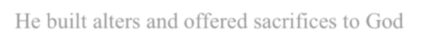

1. He brought the Ark of the Covenant to Jerusalem. The Ark of the Covenant contained the Ten Commandments and was kept in the section of the tabernacle called the holies.
2. He made Jerusalem a holy city and center of worship where all Israelites from all over the land came for important religious occasions.
3. He composed psalms which were used in worship by Israelites especially during the exile
4. He wanted to build a temple for God. However, God denied him that opportunity.
5. He repented whenever he made mistakes. For instance, after committing adultery with Uriah's wife, Bathsheba, he sought for| forgiveness from God.
6. He built alters and offered sacrifices to God
7. He showed respect to prophets of God such as Nathan.
8. He acted as a good role model by worshipping God.

**First 6x1=6 marks**



**b) Explain four life skills that Elijah used to fight against false religion in Israel. (8 marks)**



1. Assertiveness - he told Ahab that he was the cause of trouble in Israel
2. Creative thinking - He requested for a contest with prophets of Baal.
3. Decision making - he decided to kill the prophets/prophetess of Baal
4. Self- esteem - He was convinced that God was on his side
5. Negotiation - Elijah asked the Israelites to choose between God and Baal.
6. Conflict resolution - through the contest, he convinced the Israelites that Yahweh was the true God.
7. Effective communication - He explained to the people how the contest was to be carried out.
8. Self-awareness - He knew that he was the prophet of the true God/ he had confidence i n himself.
9. Critical thinking - sought ways to prove that Yahweh was true

**Note: every life skill must be shown how Elijah used it.**

**First 4x2=8 marks**



**c) Give ways in which Christian can enhance true worship of God in Kenya today (6 marks)**



1. Praying for Gods guidance
2. Reading the Bible
3. living exemplary lives
4. Giving tithes / offerings
5. Repenting and forgiving one another
6. Attending church services
7. Carrying out worship within legal framework
8. Seeking guidance and counselling from church leaders on how to worship



**Any 6x1=6 marks**

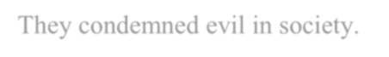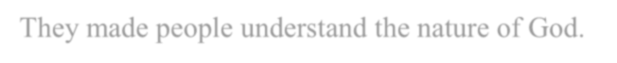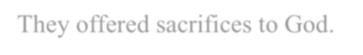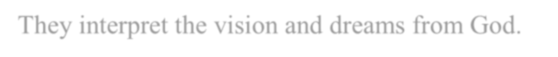

**4 a) Explain the role of prophets in the Old Testament (6 marks)**

* They spoke on behalf of God/ were God's mouth pieces.
* They foretold the future events.
* They revealed the nature of God to people.
* They acted as mediators between God and the people.
* They guided and counseled the kings/ advised kings.
* They called people back to repentance.
* They gave a message of hope to people.
* They reminded the people about the covenant way of life.
* They condemned evil in society.
* They warned people of God's judgment.
* They made people understand the nature of God.
* They offered sacrifices to God.
* They anointed kings.
* They interpret the vision and dreams from God.



**Any 6x1=6 marks**



**b) State seven ways in which the rich oppressed the poor during the time of Prophet Amos, (7 marks)**

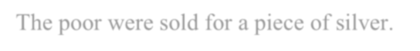

* The rich took people's garment in pledge.
* The poor were robbed of their food and belongings.
* Merchants overcharged the poor when selling them anything.
* The poor were sold for a piece of silver.
* The rich used false measuring scales in business.
* The poor were sold into slavery when they were unable to pay their | debts to the rich
* They sold products which were not fit for human consumption to the| poor.
* The poor were denied justice in law courts because they could not] bribe judges.



**First 7x1=7 marks**

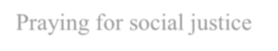

* **In what ways is the Church in Kenya promoting justice in the society (7 marks)**
  + Promoting education to the public on social justice / civic education
  + By respecting and following the laws of the country as laid down by the government
  + By providing shelter to the needy
  + Preaching on social justice
  + Praying for social justice
  + Giving food / shelter to the hungry
  + Advising government on the need for upholding justice in the society
  + Condemning acts of injustices



**Any 7x1=7 mark**

**5 a) Outline seven problems that Nehemiah encountered in rebuilding the wall of Jerusalem. (7 marks).**

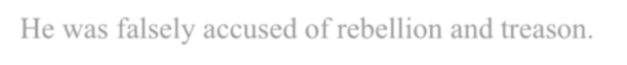

* Lack of support and cooperation when rebuilding the wall of Jerusalem from the nobles of Tekoa.
* His work of rebuilding the wall was ridiculed and despised by Sanballat and Tobiah.
* He was falsely accused of rebellion and treason.
* There was a plot to k i l l h im through the treachery of Sanballat.
* Oppression of the poor by the rich which was against the covenant way of life.
* There was violation and negligence of Sabbath observance.
* The Jews had lost their cultural identity through intermarriages w i t h foreigners.
* Threats of attacks derailed the work of reconstruction.

**First 7x1=7 marks**

**b) Explain the significance of the symbolic act of buying land by prophet Jeremiah. (6marks)**

* It shows that the people of Judah still had a future despite the coming crisis.
* t was an assurance that people would be restored back to their homeland.
* It portrayed that people would resume normal lives.
* t showed that divine judgment was not an end to itself.
* t symbolized that people would wait patiently for their return from exile.
* It showed that restoration was to take place at God's own time.
* It showed that God is faithful He keeps the promise of restoring Israelites to their ancestral land.
* It made them secure and that they will not lack anything



**Any 6x1=6 marks**



1. **State seven relevance of prophet Jeremiah’s suffering to Christians today. (7 marks)**
   * Christians should remain faithful to the call of God irrespective of challenges that they are facing.
   * Christians must be ready/Willing to proclaim the word of God always/at any time.
   * Christian should depend on God/be prayerful/draw their strength from God.
   * Christians should expect opposition while serving God.
   * Christians should forgive their offenders/not take vengeance.
   * They should be aware of false prophets in their midst.
   * They should endure/persevere during their suffering.
   * Christians should remain faithful to the call of God irrespective of challenges that they are facing.
   * Christians must be ready/Willing to proclaim the word of God always/at any time.
   * Christians should depend on God/be prayerful/draw their strength from God.
   * Christians should expect opposition while serving God.
   * Christians should forgive their offenders/not take vengeance.
   * Christians should be aware of false prophets in their midst.
   * Christians should endure/persevere during their suffering.

**First 7x1=7marks**

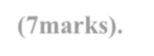

**6 a) Explain the importance of rituals performed during a naming ceremony in traditional African communities.**

**(7marks).**

1. Bathing of the baby sets in the beginning of a new life.
2. Shaving of the mother's hair symbolizes new status.
3. Choosing of the appropriate name to give to the baby is a sign of identification of the baby and honouring of ancestors.
4. Giving presents to the baby or mother is a sign of good will.
5. Feasting is a sign of joy and welcoming of the baby.
6. Slaughtering of animals is a sign of thanksgiving to ancestors and God.
7. Saying prayers and words of blessings for the mother signifies long
8. Holding the baby by members of the community shows concern for it.
9. Wearing of charms signifies protection for the baby and mother.

**Any 7x1=7marks**

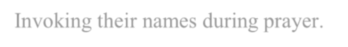

1. **What is the responsibility of the living towards the ancestors in traditional African Communities. (7 marks)**
   * Pouring libation to them.
   * Giving sacrifices to honour them.
   * Taking care of their graveyards.
   * Communicating with them in times of need.
   * Invoking their names during prayer.
   * Honoring their wishes.
   * Holding commemoration ceremonies for them.
   * Teaching children about them.
   * Managing their property wisely.
   * Building shrines for them.



**Any 7x1=7marks**

1. **State six factors that undermine the role of medicine men in Kenya today. (6 marks)**
   * Introduction of western medicine/hospitals/new inventions/science and technology



* + Emergence of new religions which do not support medicine men
  + There is destruction of forests/herbs/deforestation
  + Lack of proper education by herbalists/professionalism /lack of proper dosage
  + Herbal medicine is cumbersome to look for
  + low hygiene standards associated with herbal medicine
  + Certain chronic diseases cannot be treated by some herbs
  + Emergence of conmen/quacks who give wrong medicine
  + Urbanization/immigration from rural to urban center
  + Lack of awareness/education on herbal medicine by the public
  + Strict government policies /rules/regulation that control both herbal and modem medicine.

**First 6x1=6 marks**