URANGA PHYSICS EXAMINATION

***Kenya Certificate of Secondary Education***

**232/1** PHYSICS **Paper 1**

**(Theory)**

**4TH EDITION (JAN. 2022) – TIME 2 Hours**

# Name:………………………..……………….…………School: …………………………..…….……

**Class ……………………..Adm No………………….. …… Index Number…………………...……**

# Candidate’s Signature……………………… Date: ………………………………

**Instructions to candidates**

1. *Write your* ***name, index number, class*** *and* ***school*** *in the spaces provided above.*
2. ***Sign*** *and* ***Write*** *the date of Examination in the spaces provided above.*
3. *This paper consists of* ***two*** *sections;* ***A*** *and* ***B.*** *Answer* ***all*** *the questions in section* ***A*** *and* ***B*** *in the spaces provided.*
4. *All working* ***must*** *be clearly shown.*
5. ***Silent non-programmable*** *electronic calculators may be used.*
6. *Candidates should answer the questions in* ***English****.*

# FOR EXAMINERS USE ONLY

|  |  |  |  |
| --- | --- | --- | --- |
| **SECTION** | **QUESTIONS** | **MAXIMUM SCORE** | **CANDIDATE’S SCORE** |
| A | 1-11 | 25 |  |
| B | 12 | 16 |  |
| 13 | 08 |  |
| 14 | 09 |  |
| 15 | 12 |  |
| 16 | 10 |  |
| **TOTAL SCORE** | | **80** |  |

***This paper consists of 14 printed pages. Candidates should check the question paper to ascertain that all the pages are printed as indicated and that no questions are missing.***

# SECTION A (25 MARKS)

**Answer all the questions in this section**

* 1. A burette has an initial reading of 40.0 cm3. Some 24 drops of water each of volume 0.5cm3 are added into the instrument. What is the final volume of water in it? **(2 marks)**

…………………………………………………………………………………………..………………

……….………..………………………………………………………………….……………………

………………………………………………………………………..…………………………………

………………………………………………………………………………………………

# 2.

1. Name two forces that determine the shape of liquid drop on a solid surface. **(2 marks)**

…………………………………………………………………………………………………………

……………………………………………………………………………………………………

1. If an umbrella is touched with finger on inner surface when it is raining, it allows the rain water to leak through. Give a reason. **(1 mark)**

…………………………………………………………………………………………………………

…………………………………………………………………………………………………………

…………………………………………………………………………………………………………

……………………………………………………………………..……………

**3.** The barometric height in a town is 55cmHg. Given that the standard atmospheric pressure is 76cmHg and the density of mercury is 13.6g/cm3, determine the altitude of the town. (Density of air is 1.25kg/m3) **(2 marks)**

…………………………………………………………………………………………………………

…………………………………………………………………………………………………………

…………………………………………………………………………………………………………

……………………………………………………………………………………….…

# 4.

1. What is Brownian motion? **(1 mark)**

…………………………………………………………………………………………………………

…………………………………………………………………………………………………………

…………………………………………………………

1. A measuring cylinder contains 20cm3 of water. 10cm3 of salt is added and stirred. Explain why the new volume is not 30cm3. **(1 mark)**

…………………………………………………………………………………………………………

…………………………………………………………………………………………………………

………………………………………………………………………………………………

1. **Figure 1** shows samples of same liquid in beakers B and C being heated through a well-lagged copper rod of non-uniform thickness. A thermometer is placed on each sample for some time.

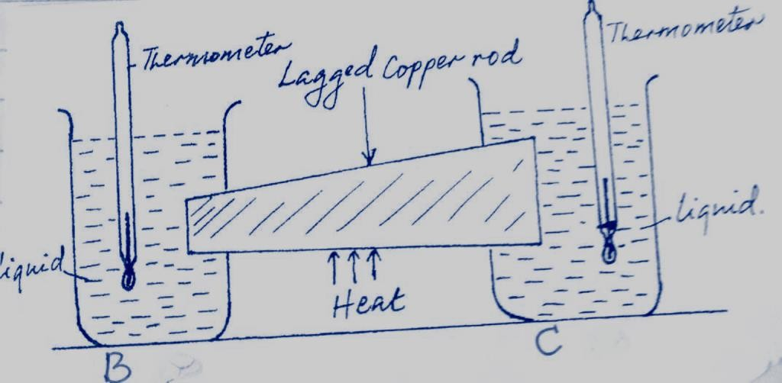

***Fig. 1***

If the rod is heated at the middle, state and explain which of thermometers records a higher temperature.

# (2 marks)

…………………………………………………………………………………………………………

…………………………………………………………………………………………………………

…………………………………………………………………………………………………

1. **Figure 2** shows a uniform meter rule balancing when a mass of 200g is hung at one end.

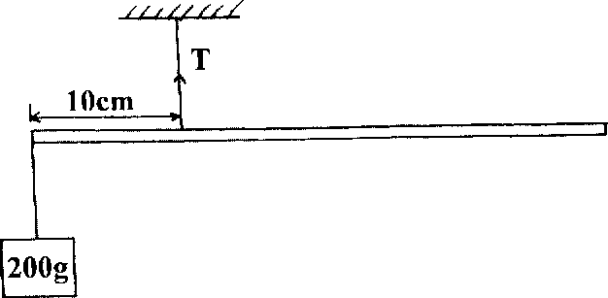

***Fig. 2***

Determine the tension T in the string. **(2 marks)**

…………………………………………………………………………………………………………

…………………………………………………………………………………………………………

…………………………………………………………………………………………………………

………………………………………………………………………………………………

1. State the Hooke’s Law. **(1 mark)**

…………………………………………………………………………………………………………

…………………………………………………………………………………………………………

…………………………………………………………………………………………………

1. **Figure 3** shows a Bunsen burner.

**Air**



**Nozzle**

**Gas tap**

**Gas**

## Fig. 3

Explain how air is drawn into the burner when the gas tap is open. **(2 marks)**

…………………………………………………………………………………………………………

…………………………………………………………………………………………………………

…………………………………………………………………………………………………………

…………………………………………………………

1. A can containing only air is tightly screwed and left in strong sunlight. Using kinetic theory of gases explain how the pressure inside the can will be affected. **(3 marks)**

…………………………………………………………………………………………………………

…………………………………………………………………………………………………………

…………………………………………………………………………………………………………

…………………………………………………………………………………………………………

…………………………………………………………………………………………………………

……………………………………………………

1. A form four girl did an experiment using a simple pendulum of length **120 cm** to determine the acceleration due to gravity. She timed for **50** oscillations (***using a stop watch***) and got the result indicated in **figure 4** below.

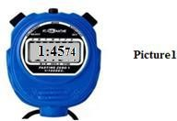

***Fig. 4***

* 1. Record the indicated time in SI units. **(1 mark)**

…………………………………………………………………………………………………………

…………………………………………………………………………………………………………

…………………………………………………………………………………

* 1. From the information above, determine the value of acceleration due to gravity, g, from the

formula 𝑻2 ***=***𝟒𝝅𝟐𝒍

𝒈

where **T** is periodic time. (Take 𝜋 = 3.142) **(3 marks)**

…………………………………………………………………………………………………………

…………………………………………………………………………………………………………

…………………………………………………………………………………………………………

…………………………………………………………………………………………………………

………………………………………………………………………………………………..…

1. A machine consists of a wheel of radius 40cm and axle of radius 10cm. Determine the efficiency of the machine when used to lift a load of 300N using an effort of 100N. **(2 marks)**

…………………………………………………………………………………………………………

…………………………………………………………………………………………………………

…………………………………………………………………………………………………………

…………………………………………………………………………………………………………

…………………………………………………………………………………………………………

………………………………………………….………………………………………………………

………………………………………………………

# SECTION B (55 MARKS)

**Answer all the questions in this section**

* 1. State the Archimedes’ principle. **(1 mark)**

…………………………………………………………………………………………………………

…………………………………………………………………………………………………………

…………………………………………………………………………………………………………

………………………………………………………………………………………………

* 1. A cork of volume 100cm3 is floating on water. If the density of the cork is 0.25 gcm-3;
     1. Calculate the mass of the cork. **(2 marks)**

…………………………………………………………………………………………………………

…………………………………………………………………………………………………………

…………………………………………………………………………………………………………

………………………………………………………………………………………………

* + 1. Find the upthrust force on the cork. **(2 marks)**

…………………………………………………………………………………………………………

…………………………………………………………………………………………………………

…………………………………………………………………………………………………………

………………………………………………………………………………………………

* + 1. What minimum force is required to immerse the cork completely? **(2 marks)**

…………………………………………………………………………………………………………

…………………………………………………………………………………………………………

…………………………………………………………………………………………………………

………………………………………………………………………………………………

* 1. The graph below shows the variation of pressure produced at the end of piston as the force is applied on it.

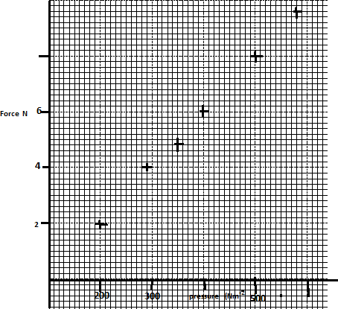

**Pressure Nm-2**

1. Draw the line of the best fit. **(1 mark)**
2. From the graph determine the area of the piston. **(3 marks)**

…………………………………………………………………………………………………………

…………………………………………………………………………………………………………

…………………………………………………………………………………………………………

………………………………………………………………………………………………………….

……………………………………………………………………………………

1. On the same graph draw a line showing the pressure produced when the same force was applied on a wider piston. **(1 mark)**

………………………………………………………………………………………………………

………………………………………………………………………………………………………

………………………………………………………………………………………………………

* 1. In construction of a mercury barometer care is taken to make sure it has no gas in the space above mercury.

1. How would you test whether there is a gas above mercury? **(1 mark)**

…………………………………………………………………………………………………………

…………………………………………………………………………………………………………

………………………………………………………………………………………………

1. State the problem caused by the presence of gas in the barometer. **(1 mark)**

…………………………………………………………………………………………………………

…………………………………………………………………………………………………………

………………………………………………………………………………………………

(d) Find the total pressure experienced by a diver 8 meters below the sea surface. (Take Atmospheric pressure = 103 360N, Density of sea water = 1030 kg/m3) **(2 marks)**

…………………………………………………………………………………………………………

…………………………………………………………………………………………………………

…………………………………………………………………………………………………………

………………………………………………………………………………………………

1. What is meant by acceleration? **(1 mark)**

…………………………………………………………………………………………………………

…………………………………………………………………………………………………………

………………………………………………………………………………………………

1. **Figure 5** shows a displacement-time graph for a rally vehicle.

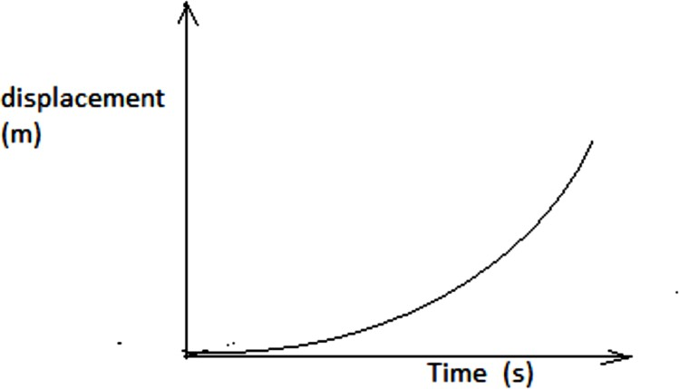

***Fig. 5***

* 1. Describe the way the vehicle is moving. **(1 mark)**

…………………………………………………………………………………………………………

* 1. Sketch a velocity-time graph for this vehicle. **(1 mark)**

1. A bullet is fired horizontally at a velocity of 400m/s from a cliff which is 50m tall as in

**figure 6** below.

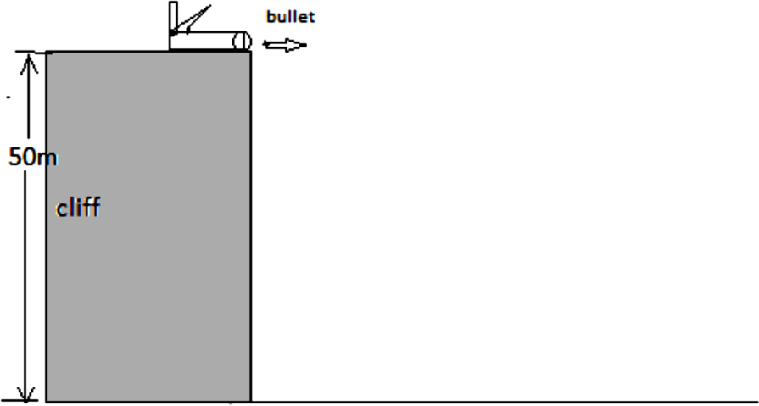

## Fig. 6

1. On the diagram draw the trajectory of the bullet until it comes to rest. **(1 mark)**
2. Find the time taken for the bullet to hit the ground. **(2 marks)**

…………………………………………………………………………………………………………

…………………………………………………………………………………………………………

…………………………………………………………………………………………………………

………………………………………………………………………………………………

1. Find the horizontal range. **(2 marks)**

…………………………………………………………………………………………………………

…………………………………………………………………………………………………………

…………………………………………………………………………………………………………

………………………………………………………………………………………………

* 1. Define the following terms. **(2 marks)**

1. Latent heat of vaporization

…………………………………………………………………………………………………………

…………………………………………………………………………………………………………

…………………………………………………………………………………………………………

………………………………………………………………………………………………

1. Specific latent heat of vaporization.

…………………………………………………………………………………………………………

…………………………………………………………………………………………………………

…………………………………………………………………………………………………………

………………………………………………………………………………………………

* 1. A beaker of mass 100g and negligible heat capacity contains 25g of water at 180C. A student heats water to produce steam at 1000C. The steam is then passed into the water for some time as shown in **figure 7 below.** After the experiment, the mass of the beaker and its contents is found to be 128g.

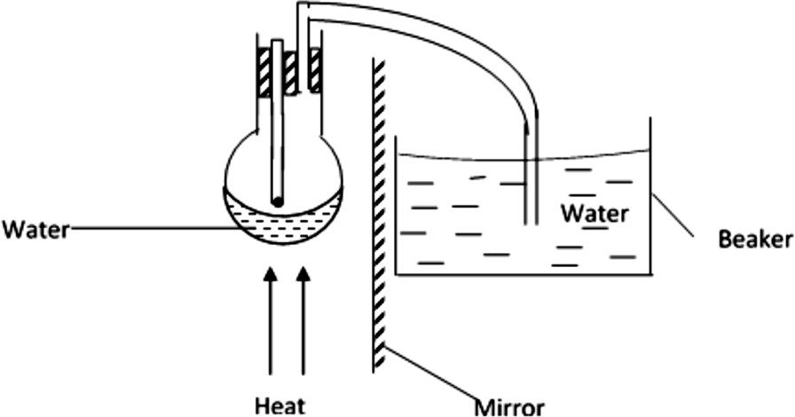

***Fig. 7***

Given that the specific latent heat of vaporization of water is 2.26 x 106 Jkg-1 and specific heat capacity of water is 4200 Jkg-1K-1.

1. Give the reason why the thermometer is placed slightly above the water surface. **(1 mark)**

…………………………………………………………………………………………………………

…………………………………………………………………………………………………………

…………………………………………………………………………………………………

1. Give the purpose of the mirror in the experiment. **(1 mark)**

…………………………………………………………………………………………………………

…………………………………………………………………………………………………………

………………………………………………………………………………………………...

1. Find the mass of steam that converted to water. **(2 marks)**

…………………………………………………………………………………………………………

…………………………………………………………………………………………………………

…………………………………………………………………………………………………………

……………………………………………………………………………………………...

1. Determine the final temperature of the water in the beaker correct to 1 decimal place. **(3 marks)**

…………………………………………………………………………………………………………

……………………………………………………………………………………………………

* 1. A small ball of mass 30g is spinning on a string of length 80cm in a horizontal circle.
     1. Which force produces the centripetal force? **(1 mark)**

…………………………………………………………………………………………………………

* + 1. Explain why the speed of the ball is constant but the velocity is not. **(1mark)**

…………………………………………………………………………………………………………

…………………………………………………………………………………………………………

………………………………………………………………………………………………

* 1. Two masses of 0.9kg and 1.8kg are attached on an inelastic string as shown in **figure 8.**

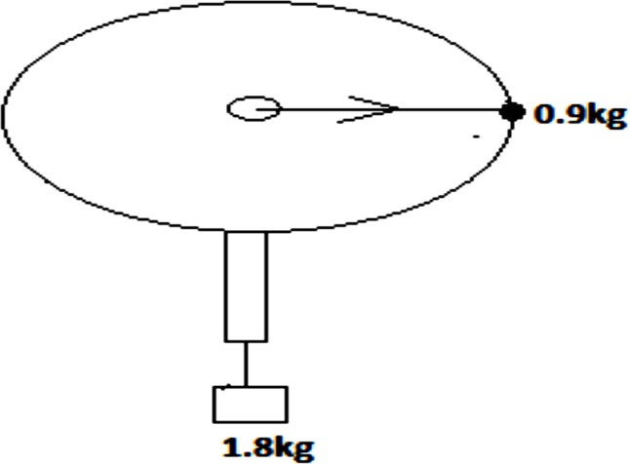

## Fig. 8

The radius of the circle through which the 0.9kg mass spins is 0.5m. Find the:

1. Tensional force that will keep the system in circular motion. **(2 marks)**

…………………………………………………………………………………………………………

…………………………………………………………………………………………………………

…………………………………………………………………………………………………………

………………………………………………………………………………………………

1. Angular velocity at which the 0.9kg mass must spin in order that the 1.8kg mass does not slide downwards. **(3 marks)**

…………………………………………………………………………………………………………

…………………………………………………………………………………………………………

…………………………………………………………………………………………………………

………………………………………………………………………………………………

* 1. An object k is at the edge of a turntable as in **figure 9**.

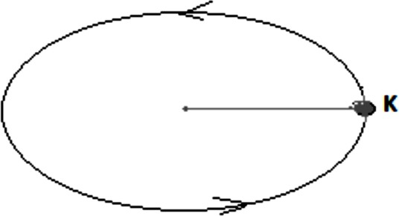

## Fig. 9

The table spins anticlockwise. What factors will affect the force acting on the object? **(2 marks)**

…………………………………………………………………………………………………………

…………………………………………………………………………………………………………

………………………………………………………………………………………………

* 1. An electron of mass 9.1x10-31 kg is spinning around an atom of radius 6.2x10-11 m at a speed of 3.0x108 m/s.

1. Determine the centripetal force acting on the electron. **(2 marks)**
2. If the electrostatic force on the electron was suddenly removed, how will the electron move?

# (1 mark)

………………………………………………………………………………………………………

………………………………………………………………………………………………………

………………………………………………………………………………………………………

………………………………………………………………………………………………………

1. A lawn tennis ball is thrown such that it hits a wall perpendicularly at a speed of 6.5m/s as in

**figure 10** and rebounds at 4.5m/s.

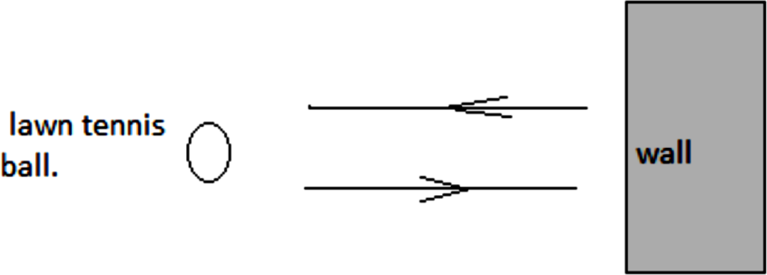

***Fig. 10***

The ball has a mass of 50g and it is in contact with the wall for 0.02s.

1. What is meant by impulse? **(1 mark)**

…………………………………………………………………………………………………………

…………………………………………………………………………………………………………

………………………………………………………………………………………………

1. Find how much force is applied to the wall by the ball. **(3 marks)**

…………………………………………………………………………………………………………

…………………………………………………………………………………………………………

…………………………………………………………………………………………………………

………………………………………………………………………………………………

1. Determine the change in momentum of the ball. **(2 marks)**
2. Giving your reason state the type of collision that the ball undergoes. **(2 marks)**

…………………………………………………………………………………………………………

…………………………………………………………………………………………………………

…………………………………………………………………………………………………………

………………………………………………………………………………………………

1. Basing your argument on Newton’s second law, explain why the athletes for high jump land on a thick soft mattress and not on a hard ground. **(2 marks)**

…………………………………………………………………………………………………………

…………………………………………………………………………………………………………

…………………………………………………………………………………………………………

………………………………………………………………………………………………

# THIS IS THE LAST PRINTED PAGE