FORM 4 PREDICTOR 2, 2025
Kenya Certificate of Secondary Education
443/ 2 - Biology - Paper 2
(Theory)
PREDICTOR 2 2025 – Time 2 hours

Name …………………………………………….……… Adm Number…………………………..
Candidate’s Signature ………………….…...……….. Date ……………………………………

Instructions to candidate
- Write your name and class in the spaces provided above.
- Sign and write the date of examination in the spaces provided above.
- This paper consists of two sections: A and B.
- Answer ALL the questions in section A in the spaces provided.
- In section B answer question 6 (compulsory) and either question 7 or question 8 in
the spaces provided after question 8Candidates should answer the questions in English.
- Candidates should check the question paper to ascertain that all the pages are printed as indicated and no questions are missing.
For Examiner’s Use Only
SECTION | QUESTION | MAXIMUM SCORE | CANDIDATES SCORE
A | 1  2  3  4  5 | 8  8  8  8  8
B | 6  7 or  8 | 20  20  20
TOTAL SCORE |  | 80 MARKS



TURN OVER

- The flow chart below shows a process in a plant and animal cell
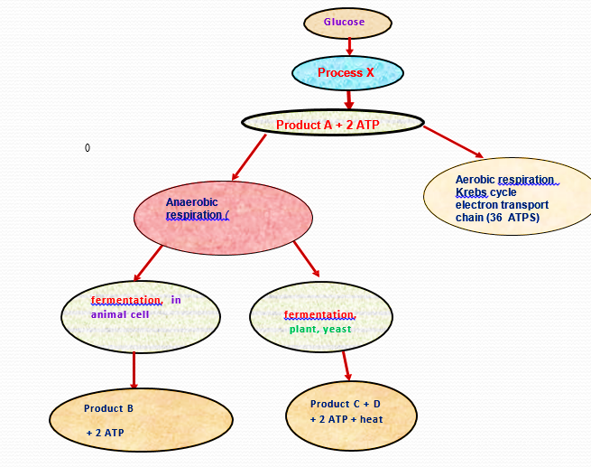
- Why is this process necessary in living organisms (3 marks)
………………………………………………………………………………………………………………………………………………………………………………………………………………………………………………………………………………………………………………………………………………………………………………………………………………………………………………………………………………………………………………………………………
- i) Name the process labelled X (2 marks)
………………………………………………………………………………………………………
ii) Name the part of the cell where process X occurs (1 marks)
………………………………………………………………………………………………………
- Name products A, B (2marks)
……………………………………………………………………………………………………………………………………………………………………………………………………………...

2. (a) Distinguish between a genotype and a phenotype. (1 mark)
........................................................................................................................................................................................................................................................................................................................................................................................................................................................................................................................................................................................................................................................................................................................................................................................................................................................................................................................................................................
(b) A couple with normal skin pigmentation had three children but their second born was an albino. Using the letter A to represent the gene for normal skin color, work out the genotypes of their children using a genetic cross. (4 marks)

(c) Apart from albinism, state other three disorders in humans caused by gene mutation. (3marks)
...........................................................................................................................................................................................................................................................................................................................................................................................................................................................................................................................................................................................................................................................................................................................................................................................................

3. Examine the drawings of the organisms shown below.
(a) Construct a dichotomous key that can be used to distinguish the organisms using the following observable features only. (6 marks)
(i) Wings
(ii) Pair of antennae
(iii) Legs per segment.
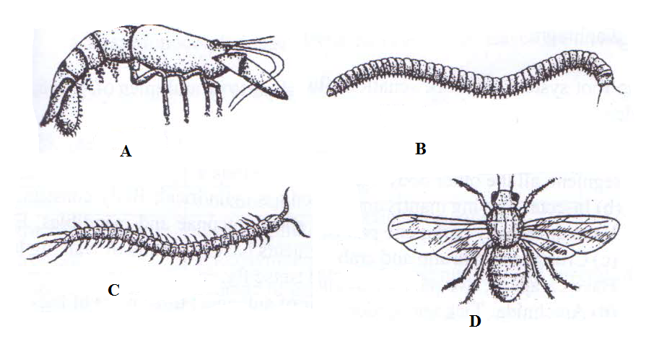
................................................................................................................................................................................................................................................................................................................................................................................................................................................................................................................................................................................................................................................................................................................................................................................................................................................................................................................................................................................................................................................................................................................................................................................................................................................
- Give two distinguishing features common to the organisms shown above in (a).
(2marks)
........................................................................................................................................................................................................................................................................................................................................................................................................................................................................................................................................................................................................................4. Use the photograph of mammalian digestive system and associated organs to answer the questions that follow.
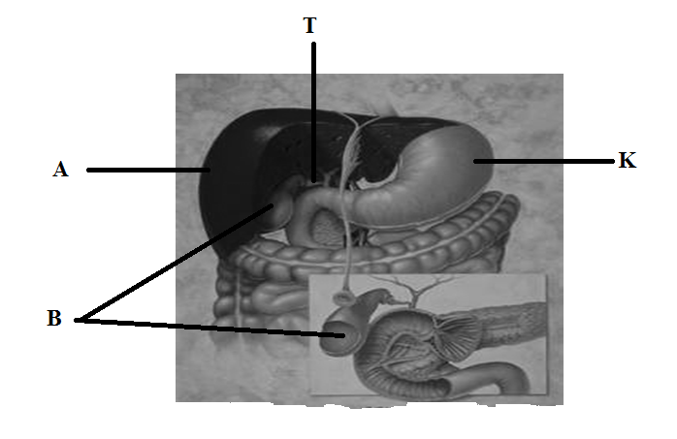

(i) Name the structures marked A, R, K andT. (4marks)
A……………………………………………………………………………………………….B……………………………………………………………………………………………….K……………………………………………………………………………………………….T………………………………………………………………………………………………..
(ii) Name an acid found in the structure labelled K. (1mark)
………………………………………………………………………………………………...
(iii) Name the juice stored in the structure labelled B and give its function. (2marks)
Juice…………………………………………………………………..…………………..
Function………………………………………………………………………………………………………………………………………………………………………………………...…………………………………………………...………………………………………………………………………………………………....................................................…
(iv) Label with letter D part where function named in (iii) above takes place. ( 1 mark)

5. The diagram below represents a neurone. Use it to answer questions that follow.
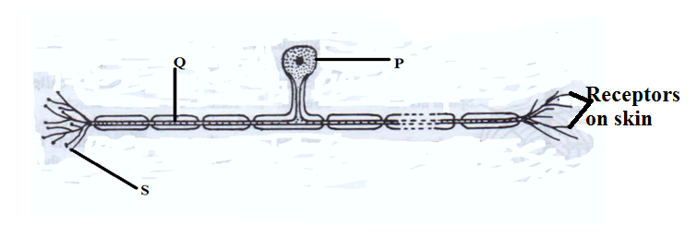
(a)Identify the neurone. (1 mark)
............................................................................................................................................................
(b) Using an arrow, show the direction of impulse. (1 mark)

(c)Name the parts labelled.
(i)Q..................................................................................................................................... (1 mark)
(ii)P......................................................................................................................................(1 mark)
(iii)S................................................................................................................................... (1 mark)
(d) Name the neurotransmitter substance released at part S. (1 mark)
..........................................................................................................................................................
(e) Identify the damaged parts of the brain that would exhibit the following symptoms.
(i) Loss of memory. (1 mark)

...........................................................................................................................................................
(ii) Inability to maintain proper body balance and posture. (1 mark)
..........................................................................................................................................................

SECTION B: 40 (MARKS)
Answer question 6 (Compulsory) and either question 7 or 8 in the spaces provided afterquestion 8.
6. An investigation was carried out to determine the concentration of various substances in a river following the discharge of untreated sewage into the river. The results are shown in the table below.
Distance downstream in kilometers | 0.0 | 0.5 | 1 | 2 | 4 | 6 | 8 | 10 | 12 | 14 | 16
Concentration of oxygen(mg/L) | 10.0 | 10.0 | 8.8 | 5.8 | 5.0 | 4.0 | 5.0 | 6.0 | 8.2 | 9.4 | 10.0
Concentration of organic matter(mg/L) | 10.0 | 10.0 | 16.0 | 15.2 | 14.2 | 13.4 | 12.6 | 12.4 | 11.6 | 10.0 | 10.0
Concentration of nitrates(mg/L) | 10.0 | 10.0 | 10.6 | 12.2 | 14.2 | 15.0 | 15.2 | 14.6 | 12.6 | 11.4 | 10.0
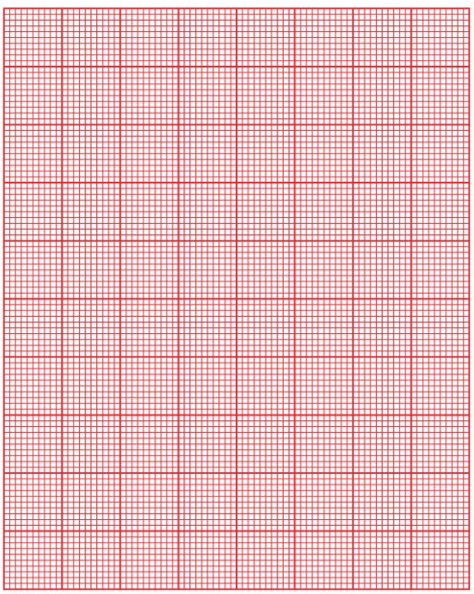
(a) Using the same axes, draw graphs of concentration of named substances in the water against kilometers. (8 marks)

(b) Identify the point of sewage discharge. (1 mark)

...........................................................................................................................................................

(c) Account for the changes in the concentration of;
(i) Organic matter. (2 marks)
................................................................................................................................................................................................................................................................................................................................................................................................................................................................................................................................................................................................................................................
(ii) Dissolved oxygen. (2 marks)
................................................................................................................................................................................................................................................................................................................................................................................................................................................................................................................................................................................................................................................
(d)Nitrates. (2mks) ................................................................................................................................................................................................................................................................................................................................................................................................................................................................................................................................................................................................................................................
(e) Explain how heavy metals in industrial effluents may accumulate in bodies of humans to toxic levels. (2 marks)
................................................................................................................................................................................................................................................................................................................................................................................................................................................................................................................................................................................................................................................

(f) State four human activities that affect population of animals in game parks. (4 marks)
........................................................................................................................................................................................................................................................................................................................................................................................................................................................................................................................................................................................................................................................................................................................................................................................................................................................................................................................................................................

7. (a) Describe the forces involved in the transport of water up the stem to the leaves. (12 marks)
(b) Describe the adaptations of the proximal convoluted tubule to its function. (8 marks)
8. (a) State the possible application of the following plant hormones in agriculture.
- Auxins.
- Gibberellins.
(b) Explain how each of the following serves as evidence of organic evolution:
(i) Fossil records. (3 marks)
(ii) Comparative anatomy. (6 marks)
(iii) Geographical distribution. (3 marks)
........................................................................................................................................................................................................................................................................................................................................................................................................................................................................................................................................................................................................................................................................................................................................................................................................................................................................................................................................................................................................................................................................................................................................................................................................................................................................................................................................................................................................................................................................................................................................................................................................................................................................................................................................................................................................................................................................................................................................................................................................................................................................................................................................................................................................................................................................................................................................................................................................................................................................................................................................................................................................................................................................................................................................................................................................................................................................................................................................................................................................................................................................................................................................................................................................................................................................................................................................................................................................................................................................................................................................................................................................................................................................................................................................................................................................................................................................................................................................................................................................................................................................................................................................................................................................................................................................................................................................................................................................................................................................................................................................................................................................................................................................................................................................................................................................................................................................
........................................................................................................................................................................................................................................................................................................................................................................................................................................................................................................................................................................................................................................................................................................................................................................................................................................................................................................................................................................................................................................................................................................................................................................................................................................................................................................................................................................................................................................................................................................................................................................................................................
............................................................................................................................................................................................................................................................................................................................................................................................................................................................................................................................................................................................................................................................................................................................................................................................................................................................................................................................................................................................................................................................................................................................................................................................................................................................................................................................................................................................................................................................................................................................................................................................................................................................................................................................................................................................................................................................................................................................................................................................................................................................................................................
........................................................................................................................................................................................................................................................................................................................................................................................................................................................................................................................................................................................................................................................................................................................................................................................................................................................................................................................................................................................................................................................................................................................................................................................................................................................................................................................................................................................................................................................................................................................................................................................................................
........................................................................................................................................................................................................................................................................................................................................................................................................................................................................................................................................................................................................................................................................................................................................................................................................................................................................................................................................................................................................................................................................................................................................................................................................................................................................................................................................................................................................................................................................................................................................................................................................................
....................................................................................................................................................................................................................................................................................................................................................................................................................................................................................................................................................................................................................................................................................................................................................................................................................................................................................................................................................................................................................................................................................................................................................................................................................................................................................................................................................................................................................................................................................................................................................................................................................................................................................................................................................................................

THIS IS THE LAST PRINTED PAGE

