NAME ……………………………………..…………………………………………… CLASS…………………………………

ADM NO …………….……….……..…..… CANDIDATE’S SIGNATURE …………..…..………..

451/1
COMPUTER STUDIES
PAPER 1 (THEORY)
TIME: 2 ½ Hours
END TERM TWO EXAMINATIONS

NAKURU NORTH JOINT EVALUATION MOCK 2025
Kenya certificate of Secondary Education
451/1
COMPUTER STUDIES
PAPER 1
(THEORY)
JULY/AUGUST
TIME: 2 ½ hours

Instructions to Candidates
- Write your name and index number in the spaces provided above.
- This Paper consists of two sections A and B.
- Answer ALL the questions in section A.
- Answer question 16 (compulsory) and any other THREE questions from section B.
- All answers should be written in the spaces provided.
- This paper consists of 11 printed pages. Candidates should check to ensure that all pages are printed as indicated and no questions are missing

FOR EXAMINER’S USE ONLY
Section | Questions | Candidate’s score
A | - 15
B | 16
B | 17
B | 18
B | 19
B | 20
B | TOTAL SCORE

Computers have evolved through a number of generations. List any 4 characteristics of the first generation of computers. (2 marks)

----------------------------------------------------------------------------------------------------------------------------------------------------------------------------------------------------------------------------------------------------------------------------------------------------------------------------------------------------------------------------------------------------------------------------------------------------------------------------------------------------

Explain the emerging trends in microcomputer technology in relation to size (1 mark)

--------------------------------------------------------------------------------------------------------------------------------------------------------------------------------------------------------------------------------------------------

Explain why smoke and Dust particles are harmful to a computer (1 mark)

--------------------------------------------------------------------------------------------------------------------------------------------------------------------------------------------------------------------------------------------------

Explain three ways that computer technology could make office more efficient (3 marks)

----------------------------------------------------------------------------------------------------------------------------------------------------------------------------------------------------------------------------------------------------------------------------------------------------------------------------------------------------------------------------------------------------------------------------------------------------------------------------------------------------

Differentiate between single- purpose programs and integrated software (2 marks)

------------------------------------------------------------------------------------------------------------------------------------------------------------------------------------------------------------------------------------------------------------------------------------------------------------------------------------------------------------------------------------------
- What is a template? ( 1mark)
------------------------------------------------------------------------------------------------------------------------------------------------------------------------------------------------------------------------------------------------------------
- Name and explain the use of the following buttons found in a spell-check dialog box
(3 marks)
- Change
------------------------------------------------------------------------------------------------------------------------------------------------------------------------------------------------------------------------------------------
- Ignore Once
------------------------------------------------------------------------------------------------------------------------------------------------------------------------------------------------------------------------------------------
- Ignore all
------------------------------------------------------------------------------------------------------------------------------------------------------------------------------------------------------------------------------------------
- Explain the following concepts as used in spreadsheets: (4marks)
- Automatic recalculation
------------------------------------------------------------------------------------------------------------------------------------------------------------------------------------------------------------------------------------------------------------------------------------------------------------------------------------
- ‘What if’ analysis
------------------------------------------------------------------------------------------------------------------------------------------------------------------------------------------------------------------------------------------------------------------------------------------------------------------------------------------------------------------------------------------------------------------------------------------------
- A formula =B5 + C4 was entered in Cell F5. What will it become when it is copied to Cell H8? (1 mark)
------------------------------------------------------------------------------------------------------------------------------

- List any two methods used to secure data in a database (2 marks)
---------------------------------------------------------------------------------------------------------------------------------------------------------------------------------------------------------------------------------------------------------------------------------------------------------------------------------------------------------------
- State three types of relationships that can be used to link tables in databases.
(3 marks)
---------------------------------------------------------------------------------------------------------------------------------------------------------------------------------------------------------------------------------------------------------------------------------------------------------------------------------------------------------------
- What is layering as used in DTP and why is it important in DTP? (2 marks)
------------------------------------------------------------------------------------------------------------------------------------------------------------------------------------------------------------------------------------------------------------

- Briefly describe three factors contributing to slower Internet access and growth in Kenya.
(3 marks)
---------------------------------------------------------------------------------------------------------------------------------------------------------------------------------------------------------------------------------------------------------------------------------------------------------------------------------------------------------------------------------------------------------------------------------------------------------------------------------------------------------------------------------------------------------------------------------------------------------
- Outline three ways of preventing piracy with regard to data and information.
(3 marks)
------------------------------------------------------------------------------------------------------------------------------------------------------------------------------------------------------------------------------------------------------------------------------------------------------------------------------------------------------------------------------------------------------------------------------------------------------------------------------------
- Convert 767₈ to hexadecimal equivalent. (2 marks)
------------------------------------------------------------------------------------------------------------------------------------------------------------------------------------------------------------------------------------------------------------------------------------------------------------------------------------------------------------------------------------------------------------------------------------------------------------------------------------------------------------------------
- State three ways of minimizing threats to data integrity. (3marks)
------------------------------------------------------------------------------------------------------------------------------------------------------------------------------------------------------------------------------------------------------------------------------------------------------------------------------------------------------------------------------------------------------------------------------------------------------------------------------------------------------------------------------------------------------------------------------------------------------------------------------------------------------
- Give three advantages of a real-time system. (3marks)
------------------------------------------------------------------------------------------------------------------------------------------------------------------------------------------------------------------------------------------------------------------------------------------------------------------------------------------------------------------------------------------------------------------------------------------------------------------------------------------------------------------------------------------------------------------------------------------------------------------------------------------------------
- What is Telecommuting?
------------------------------------------------------------------------------------------------------------------------------------------------------------------------------------------------------------------------------------------------------------
Section B.
Answer Question 16(Compulsory) and any other three Questions.

- Give two advantages of compiling a program rather than interpreting it. (2 marks)
---------------------------------------------------------------------------------------------------------------------------------------------------------------------------------------------------------------------------------------------------------------------------------------------------------------------------------------------------------------
- Give two reasons why it is necessary to have a program design. (2 marks)
---------------------------------------------------------------------------------------------------------------------------------------------------------------------------------------------------------------------------------------------------------------------------------------------------------------------------------------------------------------
- Give one advantage of pseudo codes over flowcharts in designing algorithms (1 mark)
------------------------------------------------------------------------------------------------------------------------------------------------------------------------------------------------------------------------------------------
- Michael deposits 1,000 in a bank at an interest rate of 10% per year. At the end of each year, the interest earned is added to the amount on deposit and this becomes the new deposit for the next year.
Develop a pseudo code to determine the year in which the amount accumulated first exceeds 2,000. Also for each year, print the year (starting from 1), the deposit, the Interest earned, and the total accumulated at the end of the year. (7 marks)
------------------------------------------------------------------------------------------------------------------------------------------------------------------------------------------------------------------------------------------------------------------------------------------------------------------------------------------------------------------------------------------------------------------------------------------------------------------------------------------------------------------------------------------------------------------------------------------------------------------------------------------------------------------------------------------------------------------------------------------------------------------------------------------------------------------------------------------------------------------------------------------------------------------------------------------------------------------------------------------------------------------------------------------------------------------------------------------------------------------------------------------------------------------------------------------------------------------------------------------------------------------------------------------------------------------------------------------------------------------------------------------------------------------------------------------------------------
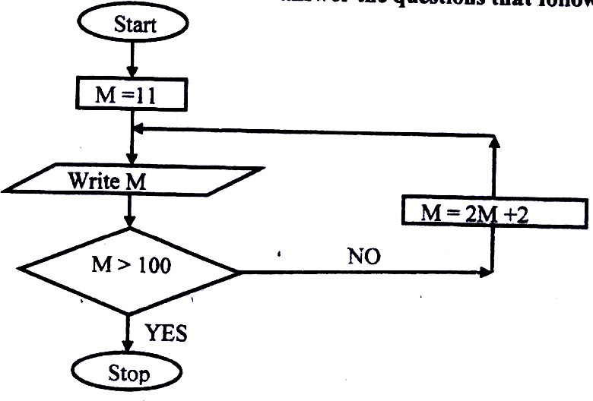
- Study the flowchart below and answer the questions that follow:
List all the outputs from the flowchart. (3 marks)
--------------------------------------------------------------------------------------------------------------------------------------------------------------------------------------------------------------------------------
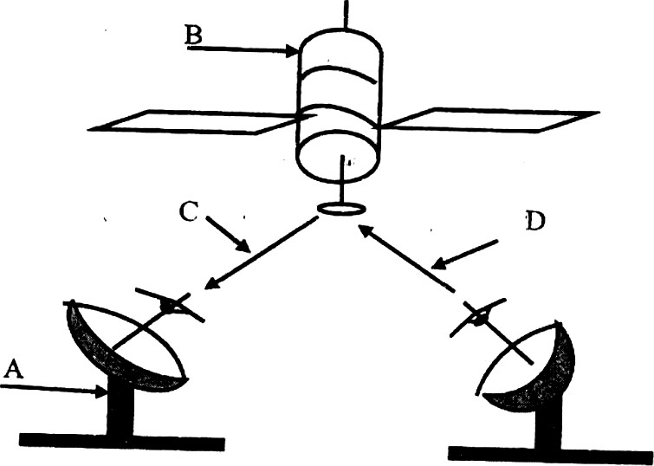
- Study the diagram below and answer the questions that follow:
- Name the communication media depicted in the above diagram. (1 mark)
---------------------------------------------------------------------------------------------------------------------
- Name the parts labelled A, B, C, and D. (4 marks)
--------------------------------------------------------------------------------------------------------------------------------------------------------------------------------------------------------------------------------------------------------------------------------------------------------------------------------------------------------------------------------------------------------------------------------------------------------------------------------------------------------------------------------------------------------------------------------------------------------
- List three advantages of the above communication media. (3marks)
------------------------------------------------------------------------------------------------------------------------------------------------------------------------------------------------------------------------------------------------------------------------------------------------------------------------------------------------------------------------------------------------------------------------------------------------
- Distinguish between logical and physical network topology. (2marks)
-----------------------------------------------------------------------------------------------------------------------------------------------------------------------------------------------------------------------------------------------------------------------------------------------------------------------------------------------------------------------------------------------------------------------------------------------------------------------------------

Explain the function of the following network devices: (2 marks)
- Network interface card (NIC)
--------------------------------------------------------------------------------------------------------------------------------------------------------------------------------------------------------------------------------------------------
- Repeater
--------------------------------------------------------------------------------------------------------------------------------------------------------------------------------------------------------------------------------------------------
- Give three advantages of using fibre optic cables for data transmission. (3 marks)
--------------------------------------------------------------------------------------------------------------------------------------------------------------------------------------------------------------------------------------------------------------------------------------------------------------------------------------------------------------------------------------------------------------------------------------------------------------------------------------------------------------------------------------------

- Outline four devices required in order to conduct a video conference. (4 marks)
---------------------------------------------------------------------------------------------------------------------------------------------------------------------------------------------------------------------------------------------------------------------------------------------------------------------------------------------------------------------------------------------------------------------------------------------------------------------------------------------------

- Describe how computing has been applied to each of the following areas:
- Transportation systems. (2 marks)
------------------------------------------------------------------------------------------------------------------------------------------------------------------------------------------------------------------------------------------------------------------------------------------------------------------------------------------------------------------------------------------
- Reservation systems. (2 marks)
------------------------------------------------------------------------------------------------------------------------------------------------------------------------------------------------------------------------------------------------------------------------------------------------------------------------------------------------------------------------------------------
- Distinguish between “job replacement” and “job displacement” in reference to Computerization (2 marks)
------------------------------------------------------------------------------------------------------------------------------------------------------------------------------------------------------------------------------------------------------------------------------------------------------------------------------------------------------------------------------------------------------------------------------------------------------------------------------------------------------------------------
- Discuss the applications of Artificial Intelligence in Expert Systems. (2 marks)
------------------------------------------------------------------------------------------------------------------------------------------------------------------------------------------------------------------------------------------------------------------------------------------------------------------------------------------------------------------------------------------------------------------------
- State three reasons why users may resist the introduction of information and communication Technology (ICT) to their place of work. (3marks)
------------------------------------------------------------------------------------------------------------------------------------------------------------------------------------------------------------------------------------------------------------------------------------------------------------------------------------------------------------------------------------------------------------------------------------------------------------------------------------------------------------------------------------------------------------------------------------------------------------------------------------------------------------------------------------------------------------------------------------------------------

  - Name any threes computing resources that can be distributed. (3 marks)
----------------------------------------------------------------------------------------------------------------------------------------------------------------------------------------------------------------------------------------------------------------------------------------------------------------------------------------------------------------------------------------------------------------------------------------------------------------
  - Define the term data integrity. (2 marks)
------------------------------------------------------------------------------------------------------------------------------------------------------------------------------------------------------------------------------------------------------------------------------------------------------------------------------------------------
  - State two reasons for using binary in digital technology. (2 marks)
------------------------------------------------------------------------------------------------------------------------------------------------------------------------------------------------------------------------------------------------------------------------------------------------------------------------------------------------
  - State the importance of hexadecimal notation in a data representation. (2 marks)
------------------------------------------------------------------------------------------------------------------------------------------------------------------------------------------------------------------------------------------------------------------------------------------------------------------------------------------------

Use Two’s compliment to subtract 101 from 1000: (2 marks)

----------------------------------------------------------------------------------------------------------------------------------------------------------------------------------------------------------------------------------------------------------------------------------------------------------------------------------------------------------------------------------------------------------------------------------------------------------------------------------------------------------------------------------------------------------------------------------------------------------------------------------------------------------------------------------------------------------------------------------------------------------------------------------------------------------------
  - Perform the following conversions:
- 7.125₁₀ to binary (2 marks)
-----------------------------------------------------------------------------------------------------------------------------------------------------------------------------------------------------------------------------------------------------------------------------------------------------------------------------------------------------------------------------------------------------------------------------------------------

7AB₁₆ to decimal (2 marks)

---------------------------------------------------------------------------------------------------------------------------------------------------------------------------------------------------------------------------------------------------------------------------------------------------------------------------------------------------------------------------------------------------------------------------------------------------------------
- Study the worksheet below and answer the questions that follow:

 | A | B | C | D | E | F
1
2 | SKYWAYS AGENCIES
3 | PRODUCT | REGION 1 | REGION 2 | REGION 3 | REGION 4 | TOTAL  Sale
4 | Rexona | 3400 | 3,700 | 4000 | 4100
5 | Lifebuoy | 2500 | 2600 | 2100 | 2500
6 | Omo | 6000 | 6100 | 6300 | 1600
7 | Ushindi | 1200 | 1500 | 1400 | 6400
8 | Carmel | 7000 | 6900 | 7200 | 8000
9 | Total
10 | Maximum
11 | Average
- Write functions that can be entered to get total, maximum, and average of each region. (3 marks)
------------------------------------------------------------------------------------------------------------------------------------------------------------------------------------------------------------------------------------------------------------------------------------------------------------------------------------------------------------------------------------------------------------------------------------------------

- Write down the function that returns the number of sales in the four regions whose value is greater than or equal to 2000. (2 marks)
------------------------------------------------------------------------------------------------------------

- The function = sum (B4:E4) is entered at F5 and then copied to F8. Write down the function as it appears in the destination cell. (2 marks)
---------------------------------------------------------------------------------------------------------------
- Define the term normalization as used in database design. (2 marks)
------------------------------------------------------------------------------------------------------------------------------------------------------------------------------------------------------------------------------------------------------------------------------------------------------------------------------------

State two objectives of normalization. (2 marks)

------------------------------------------------------------------------------------------------------------------------------------------------------------------------------------------------------------------------------------------------------------------------------------------------------------------------------------------------------------------------------------------------------------------------------------------------

Explain how ‘parents’ and ‘child’ tables are related in relational databases.

(4 marks)

------------------------------------------------------------------------------------------------------------------------------------------------------------------------------------------------------------------------------------------------------------------------------------------------------------------------------------------------------------------------------------------------------------------------------------------------

