**Name: ………………………………………………………Class: …….Adm.No. ……………**

**232/1 Candidate’s Signature: …………………...**

**PHYSICS**

**Paper 1**

**SEPTEMBER 1st**

**Time: 2 hours**

**TRIALS E X A M I N A T I O N**

**Kenya Certificate of Secondary Education**

**Instructions to Candidates**

* *Write your name, admission number, class and signature in the spaces provided at the top of the page. This paper consists of two sections;* ***A*** *and* ***B.***
* *Answer* ***ALL*** *the questions in the spaces provided.*
* *Mathematical tables and electronic calculator may be used.*
* *This paper consists of 11 printed pages.*
* *Candidates should answer the questions in English*
* *You may use the following constants where necessary:-*

g= 10N/kg, or m/s2

Density of water=1000kg/m3

**FOR EXAMINER’S USE ONLY**

|  |  |  |  |
| --- | --- | --- | --- |
| **SECTION** | **QUESTIONS** | **MAXIMUM SCORE** | **CANDIDATE’S SCORE** |
| **A** | 1 – 12 | 25 |  |
| **B** | 13 | 10 |  |
|  | 14 | 10 |  |
|  | 15 | 10 |  |
|  | 16 | 10 |  |
|  | 17 | 10 |  |
|  | 18 | 05 |  |
| **TOTAL SCORE** | | **80** |  |

**SECTION A(25Marks)**

1.Distinguish between mass and weight of a body. (1mark)

……………………………………………………………………………………………………………………………………………………………………………………………………

……………………………………………………………………………………………………………………………………………………………………………………………………

2.A density bottle full of water weighs 45g:when full of mercury of relative density 13.6,it weighs 360g.Calculate the weight of the empty density bottle. (3marks)

…………………………………………………………………………………………………………………………………………………………………………………………………………………………………………………………………………………………………………………………………………………………………………………………………………

3.Needle floats on clean water but sinks when some detergent is added to the water, explain. (1mark)

……………………………………………………………………………………………………………………………………………………………………………………………………

……………………………………………………………………………………………………………………………………………………………………………………………………

4.State two reasons why water is unsuitable as a thermometric liquid. (2marks)

……………………………………………………………………………………………………………………………………………………………………………………………………

5.State how the density of water change as the temperature is lowered say from 150C to freezing point. (2marks)

……………………………………………………………………………………………………………………………………………………………………………………………………

……………………………………………………………………………………………………………………………………………………………………………………………………

6.Explain how a vacuum flask is able to minimize heat loss by radiation. (1mark)

……………………………………………………………………………………………………………………………………………………………………………………………………

7.How is the boiling point of water affected by the addition of salt to the water. (1mark)

……………………………………………………………………………………………………………………………………………………………………………………………………

8.State two practical applications of the Principle of transmission of pressure in

Fluids. (2marks)

……………………………………………………………………………………………………………………………………………………………………………………………………

9.A uniform rod 1m long weighing 50N is supported horizontally on two knife

-edges A and B placed 10cm from its ends.Calculate the reaction at support A when a 100N weight is suspended 10cm from the midpoint of the rod towards A. (3 marks)

……………………………………………………………………………………………………………………………………………………………………………………………………

……………………………………………………………………………………………………………………………………………………………………………………………………

10.State two ways in which a lab Bunsen burner is able to keep its stable state of equillibrium (2marks)

……………………………………………………………………………………………………………………………………………………………………………………………………

11. The graph below represents relationship between extension (cm) and weight (N) suspended on a spring

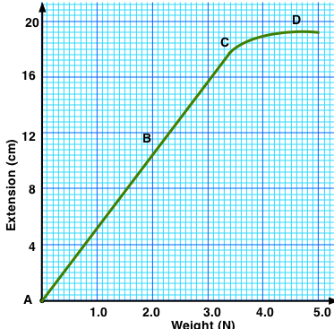

( a) Determine the spring constant of the spring (3 marks)

……………………………………………………………………………………………………………………………………………………………………………………………………

……………………………………………………………………………………………………………………………………………………………………………………………………

(b)If two such identical springs are arranged in series and support a load of 2.5N,determine the total extension of the system (2 marks)

……………………………………………………………………………………………………………………………………………………………………………………………………

……………………………………………………………………………………………………………………………………………………………………………………………………

12.A stone of mass 2kg is released from a height of 45m from the ground.Determine the momentum of the stone as it strikes the ground. (2marks)

……………………………………………………………………………………………………………………………………………………………………………………………………

……………………………………………………………………………………………………………………………………………………………………………………………………

**SECTION B(55Marks)**

13(a)

1. State Newton’s first law of motion (1 mark)

……………………………………………………………………………………………………………………………………………………………………………………………………

1. What is the relation between force and momentum (2 marks)

……………………………………………………………………………………………………………………………………………………………………………………………………

……………………………………………………………………………………………………………………………………………………………………………………………………

1. A minibus of mass 2250kg moving at 90km/h collides head on with a stationary car of mass 1250kg. If the impact takes 4 seconds before the two move together at a common velocity. Determine
2. The common velocity (2 marks)

……………………………………………………………………………………………………………………………………………………………………………………………………

……………………………………………………………………………………………………………………………………………………………………………………………………

1. The impulse of minibus (3 marks)

……………………………………………………………………………………………………………………………………………………………………………………………………

……………………………………………………………………………………………………………………………………………………………………………………………………

14.The diagram in figure below shows an experiment to investigate the relationship between volume and temperature of a fixed mass of gas at constant pressure.

**Dry air**

**Scale**

**Conc. Sulphuric acid bead**

**Thermometer**

**Stirrer**

**Water bath**

**Heat**

(a)i) Explain the function of Concentrated sulphuric acid (1mark)

……………………………………………………………………………………………………………………………………………………………………………………………………

(ii) State two measurements to be taken in the above experiment (2marks)

……………………………………………………………………………………………………………………………………………………………………………………………………

1. State law being investigated in the experiment above. (1mark)

……………………………………………………………………………………………………………………………………………………………………………………………………

iv)Name two physical properties to be kept constant in this experiment (2marks)

……………………………………………………………………………………………………………………………………………………………………………………………………

(b)On the grid shown in figure below sketch a graph of volume (cm3) against temperature (0C) for the experiment above. Clearly mark with the letter T the absolute zero temperature. (2 marks)

**-100**

**Volume (cm3)**

**Temperature 0 C**

**-100**

**0**

**-300**

**-200**

c)Use kinetic theory of gases to explain the Law in (a)i) above. (2 marks)

……………………………………………………………………………………………………………………………………………………………………………………………………

……………………………………………………………………………………………………………………………………………………………………………………………………

15. a)The figure below shows the cross – section of a wheel and axle of radius 6.5 cm and 1.5 cm

respectively used to lift a load. Use it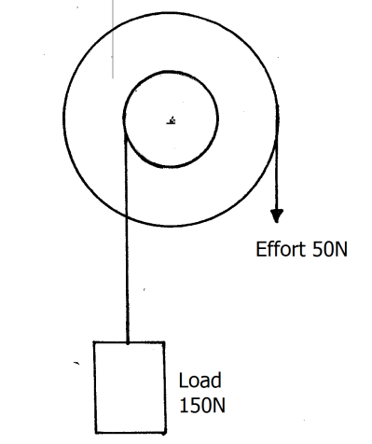 to answer the questions that follow

**Calculate:**

(i) The mechanical advantage (M.A) of the system. (2marks)

……………………………………………………………………………………………………………………………………………………………………………………………………

(ii) The velocity ratio ( V.R) of the system. (2marks)

……………………………………………………………………………………………………………………………………………………………………………………………………

(iii) The efficiency of the machine. (2marks)

……………………………………………………………………………………………………………………………………………………………………………………………………

……………………………………………………………………………………………………………………………………………………………………………………………………

b) Define the term elastic potential energy. (1mark)

……………………………………………………………………………………………………………………………………………………………………………………………………

c)30g of water are allowed to fall down a balcony.

i) Calculate the height of the balcony if the water hits the ground with a velocity of 30m/s. (2marks)

……………………………………………………………………………………………………………………………………………………………………………………………………

……………………………………………………………………………………………………………………………………………………………………………………………………

Ii) State the energy changes by the water. (1mark)

……………………………………………………………………………………………………………………………………………………………………………………………………

16. (a) A paper tape was attached to a moving trolley and allowed to run through a ticker timer. The figure below shows the section of the tape.

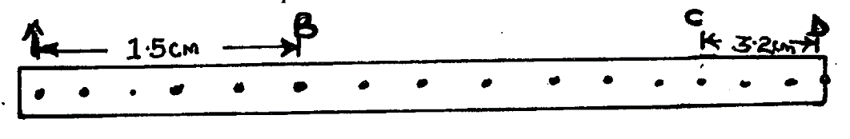

If the frequency of the tape is 100Hz, determine:

(i) Velocity at AB. (1mark)

………………………………………………………………………………………………………………………………………………………………………………………………………………………………………………………………………………………………………………………

(ii)Velocity at CD. (1mark)

………………………………………………………………………………………………………………………………………………………………………………………………………………………………………………………………………………………………………………………

(iii)Acceleration of the trolley. (2 marks)

………………………………………………………………………………………………………………………………………………………………………………………………………………………………………………………………………………………………………………………………………………………………………………………………………………………………………………………………………………………………………………………………………

b) (i) Define the term angular velocity. (1 mark)

……………………………………………………………………………………………………………………………………………………………………………………………………………… c)The figure below shows a spring tied to an object of mass M and made to rotate in a circular path of radius r.

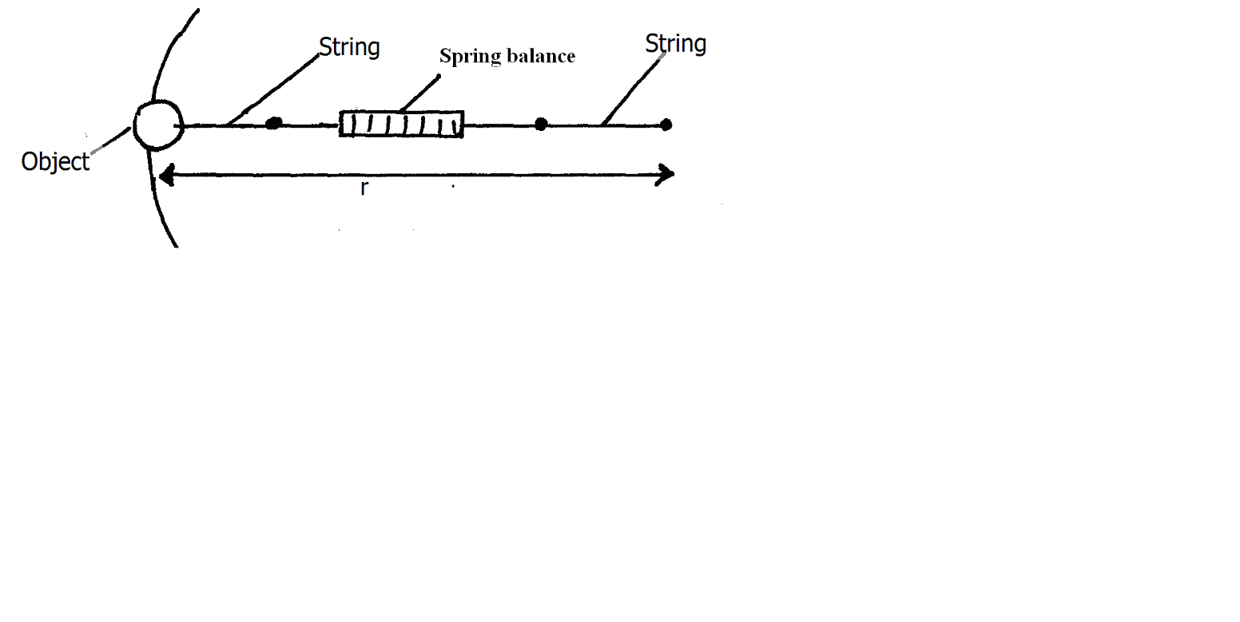

State and explain the observation that would be made on the spring balance if the object is whirled faster. (2 marks)

………………………………………………………………………………………………………………………………………………………………………………………………………………

d)The figure below shows an object of mass 0.5kg whirled in a vertical circle at a velocity of 5m/s as shown by a string 0.2m long.

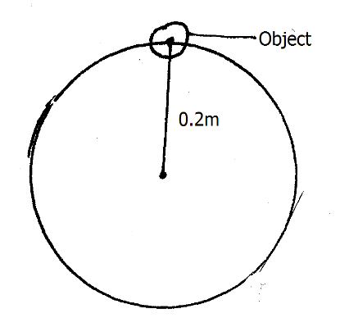

Determine the tension in the string when the object is at the position shown. (3 marks)

………………………………………………………………………………………………………………………………………………………………………………………………………………………………………………………………………………………………………………………………………………………………………………………………………………………………………………………………………………………………………………………………………

17.An electric kettle with a 2.4kW heating element has a heat capacity of 400J/k. Water of mass 1.0Kg at 20oC is placed in the kettle. The kettle is switched on and is found that 13 minutes later the mass of the water in it is 0.5Kg. (Neglecting heat losses and taking S.H.C of water = 4200J/Kg/k)

a) calculate;

i)total heat supplied. (2 marks)

………………………………………………………………………………………………………………………………………………………………………………………………………………………………………………………………………………………………………………………………………………………………………………………………………………………………………………………………………………………………………………………………………

ii)heat used for kettle. (1 mark)

………………………………………………………………………………………………………………………………………………………………………………………………………………

iii)heat used to raise temperature of 1Kg of water from 200C to 100oC. (2 marks)

……………………………………………………………………………………………………………………………………………………………………………………………………

……………………………………………………………………………………………………………………………………………………………………………………………………

iv)heat to change water at 100oC to steam at 100oC. (2 marks)

………………………………………………………………………………………………………………………………………………………………………………………………………………………………………………………………………………………………………………………………………………………………………………………………………………………………………………………………………………………………………………………………………

v) a value of specific latent heat of vaporization of water. (2 marks)

………………………………………………………………………………………………………………………………………………………………………………………………………………………………………………………………………………………………………………………………………………………………………………………………………………………………………………………………………………………………………………………………………

b) State one advantage of using continuous flow method for measuring the specific heat capacity of water. (1 mark)

………………………………………………………………………………………………………………………………………………………………………………………………………………

c)Nevin spilt a little surgical spirit on the back of her hand and her hand felt very cold. Explain. (1 mark)

………………………………………………………………………………………………………………………………………………………………………………………………………………

d)Define specific latent heat of fusion of a substance. (1 mark)

………………………………………………………………………………………………………………………………………………………………………………………………………………………………………………………………………………………………………………………………………………………………………………………………………………………………

18.a) A piece of wax weighs 0.27N in air and 0.12N when completely immersed in water. Calculate;

i)its relative density. (2 marks)

……………………………………………………………………………………………………………………………………………………………………………………………………

……………………………………………………………………………………………………………………………………………………………………………………………………

ii)its apparent weight when completely immersed in a liquid of density 0.8g/cm3. (2 marks)

……………………………………………………………………………………………………………………………………………………………………………………………………

……………………………………………………………………………………………………………………………………………………………………………………………………

b) Use Archimedes principle to explain the upward motion of a hydrogen balloon. (1 mark)

……………………………………………………………………………………………………………………………………………………………………………………………………

……………………………………………………………………………………………………………………………………………………………………………………………………